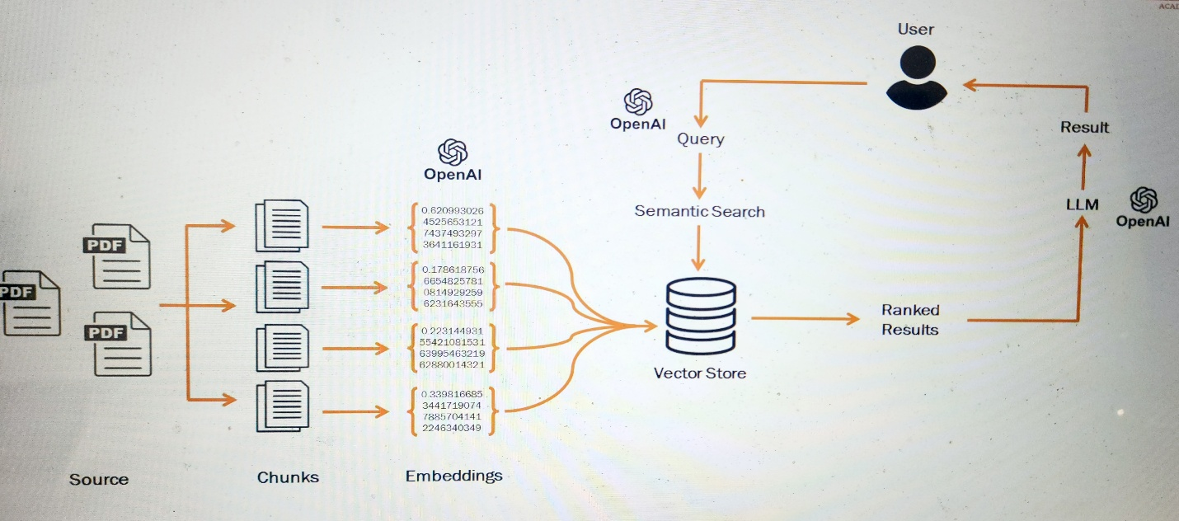
The diagram shows a Retrieval-Augmented Generation (RAG) pipeline. It combines a vector database (semantic search) with an LLM to answer questions using your own documents (like PDFs). Here’s the flow step-by-step, from left to right.

1) Source documents (PDFs)
You start with raw data:
- PDFs, Word files, web pages, etc.
- These are unstructured text and cannot be searched semantically in their raw form.
Purpose: provide the knowledge base for the system.

2) Chunking (splitting documents)
Each document is split into smaller pieces called chunks:
- Example: 300–1,000 tokens per chunk
- Often with overlap (e.g., 20–100 tokens) to preserve context
Why chunking is needed:
- Embedding models have token limits
- Smaller chunks → more precise retrieval
- Improves relevance and reduces noise
Example:
PDF → Page text → Paragraphs → Chunks

3) Embeddings (using OpenAI)
Each chunk is sent to OpenAI’s embedding model:
- Output: a vector like
[0.6209, 0.4525, 0.7437, ...] (hundreds or thousands of numbers)
- This vector represents the semantic meaning of the text
Important:
- Similar meanings → vectors close together in space
- Different meanings → far apart
This converts text into something machines can search mathematically.

4) Vector Store (database)
All embeddings are stored in a vector database, such as:
- Pinecone
- Weaviate
- FAISS
- Milvus
- Chroma
- PostgreSQL + pgvector
Stored data:
- The vector (embedding)
- The original chunk text
- Metadata (document name, page number, etc.)
Purpose:
- Enable fast similarity search using math (cosine similarity / dot product)

5) User query
User asks a question:
“What is the refund policy?”
The query is:
- Sent to OpenAI
- Converted into an embedding vector using the same embedding model
Now the system has:
- Query vector
- Millions of document vectors

6) Semantic search in vector store
The system performs:
“Find the chunks whose vectors are closest to the query vector”
This is semantic search, not keyword search.
Results:
- Top K chunks (e.g., 3–10)
- Ranked by similarity score
Output: Ranked Results

7) Send retrieved context to the LLM
The system builds a prompt like:
System: You are a helpful assistant.
User question: "What is the refund policy?"

Context:
- Chunk 1 text
- Chunk 2 text
- Chunk 3 text
These chunks are injected into the LLM prompt.

8) LLM generates the final answer
The LLM (OpenAI GPT model):
- Reads the question
- Uses the retrieved chunks as factual context
- Generates a natural language answer
This answer is returned to the user.

Why this architecture is powerful
✅ Solves key LLM limitations
Problem | Solution
LLM doesn’t know your private data | Add vector store
Hallucinations | Ground answers in retrieved text
Token limits | Chunking
Knowledge updates | Re-embed new documents

Summary in one sentence
This system:
Converts documents into embeddings, stores them in a vector database, retrieves the most relevant chunks for a user query using semantic search, and feeds them to an LLM to generate accurate, context-aware answers.

Real-world use cases
- Chat with company documents
- Customer support bots
- Legal/medical document search
- Internal knowledge bases
- E-learning assistants

